**CENWP-OD-*J 5/24/2013***

**MEMORANDUM FOR THE RECORD**

**SUBJECT: *23JDA22 Tree pulled from SFL exit trash rack***

On Tuesday 23 May 2023 a Juniper tree was removed with a crane from the South fish ladder exit trash rack. Previous inspections did not indicate any increased differentials between the forebay and ladder exit staff gauges. A crane had to be mobilized and parked on the roadway above the fish ladder exit for approximately 1 hour for the salvage operation.

Future and Preventative Measures – Fisheries routinely inspects the trash rack differentials 2x daily.

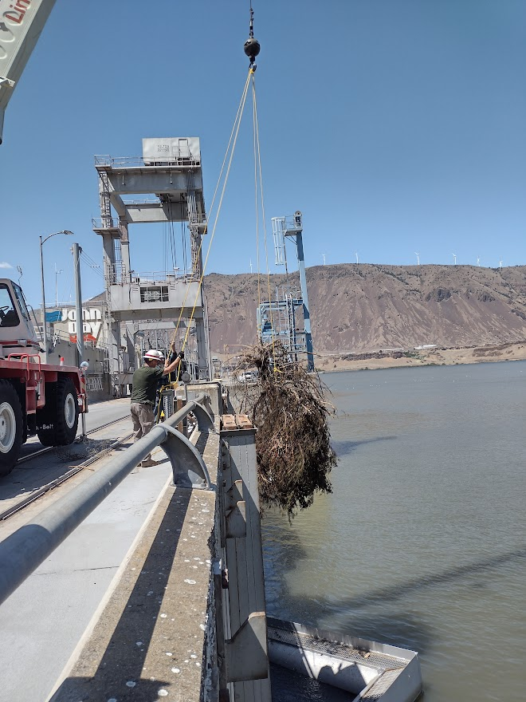

Sincerely,

Project Fisheries